|  |  |  |  |  |  |
| --- | --- | --- | --- | --- | --- |
| https://mylearning-products.accenture.com/SEF_ADMv3/ADF_ADM/cImages/completed.gif |  | | Welcome to the Course | | |
| **https://mylearning-products.accenture.com/SEF_ADMv3/ADF_ADM/cImages/twistie_closed_n.gif** | | https://mylearning-products.accenture.com/SEF_ADMv3/ADF_ADM/cImages/completed.gif | |  | Accenture Delivery Suite Strategy & Vision | |

|  |  |  |  |  |
| --- | --- | --- | --- | --- |
| **https://mylearning-products.accenture.com/SEF_ADMv3/ADF_ADM/cImages/twistie_closed_n.gif** | https://mylearning-products.accenture.com/SEF_ADMv3/ADF_ADM/cImages/completed.gif |  | Accenture Delivery Suite Overview / Components | |
| **https://mylearning-products.accenture.com/SEF_ADMv3/ADF_ADM/cImages/twistie_closed_n.gif** | https://mylearning-products.accenture.com/SEF_ADMv3/ADF_ADM/cImages/in_progress.gif |  | ADM Structure, Navigation, and Scope |

|  |  |  |  |
| --- | --- | --- | --- |
| **https://mylearning-products.accenture.com/SEF_ADMv3/ADF_ADM/cImages/twistie_closed_n.gif** | https://mylearning-products.accenture.com/SEF_ADMv3/ADF_ADM/cImages/not_started.gif |  | ADM Walkthrough |
| **https://mylearning-products.accenture.com/SEF_ADMv3/ADF_ADM/cImages/twistie_closed_n.gif** | https://mylearning-products.accenture.com/SEF_ADMv3/ADF_ADM/cImages/not_started.gif |  | Plan Stage Walkthrough | |

|  |  |  |  |  |
| --- | --- | --- | --- | --- |
| **https://mylearning-products.accenture.com/SEF_ADMv3/ADF_ADM/cImages/twistie_closed_n.gif** | https://mylearning-products.accenture.com/SEF_ADMv3/ADF_ADM/cImages/not_started.gif |  | Analyze Stage Walkthrough | |
| **https://mylearning-products.accenture.com/SEF_ADMv3/ADF_ADM/cImages/twistie_closed_n.gif** | https://mylearning-products.accenture.com/SEF_ADMv3/ADF_ADM/cImages/not_started.gif |  | Design Stage Walkthrough |

|  |  |  |  |
| --- | --- | --- | --- |
| **https://mylearning-products.accenture.com/SEF_ADMv3/ADF_ADM/cImages/twistie_closed_n.gif** | https://mylearning-products.accenture.com/SEF_ADMv3/ADF_ADM/cImages/not_started.gif |  | Build Stage Walkthrough |
| **https://mylearning-products.accenture.com/SEF_ADMv3/ADF_ADM/cImages/twistie_closed_n.gif** | https://mylearning-products.accenture.com/SEF_ADMv3/ADF_ADM/cImages/not_started.gif |  | Test and Deploy Stage Walkthroughs | |

|  |  |  |  |
| --- | --- | --- | --- |
| **https://mylearning-products.accenture.com/SEF_ADMv3/ADF_ADM/cImages/twistie_closed_n.gif** | https://mylearning-products.accenture.com/SEF_ADMv3/ADF_ADM/cImages/in_progress.gif |  | Quality Overview |
| **https://mylearning-products.accenture.com/SEF_ADMv3/ADF_ADM/cImages/twistie_closed_n.gif** | https://mylearning-products.accenture.com/SEF_ADMv3/ADF_ADM/cImages/completed.gif |  | Transition Point Overview | |

|  |  |  |  |  |
| --- | --- | --- | --- | --- |
| **https://mylearning-products.accenture.com/SEF_ADMv3/ADF_ADM/cImages/twistie_closed_n.gif** | https://mylearning-products.accenture.com/SEF_ADMv3/ADF_ADM/cImages/completed.gif |  | When to use ADM | |
| **https://mylearning-products.accenture.com/SEF_ADMv3/ADF_ADM/cImages/twistie_closed_n.gif** | https://mylearning-products.accenture.com/SEF_ADMv3/ADF_ADM/cImages/completed.gif |  | Applying ADM |

|  |  |  |  |
| --- | --- | --- | --- |
| **https://mylearning-products.accenture.com/SEF_ADMv3/ADF_ADM/cImages/twistie_closed_n.gif** | https://mylearning-products.accenture.com/SEF_ADMv3/ADF_ADM/cImages/completed.gif |  | ADM Estimators Overview |
| **https://mylearning-products.accenture.com/SEF_ADMv3/ADF_ADM/cImages/twistie_closed_n.gif** | https://mylearning-products.accenture.com/SEF_ADMv3/ADF_ADM/cImages/completed.gif |  | Harvesting and Continuous Improvement Overview | |

|  |  |  |  |  |  |  |
| --- | --- | --- | --- | --- | --- | --- |
| **https://mylearning-products.accenture.com/SEF_ADMv3/ADF_ADM/cImages/twistie_closed_n.gif** | https://mylearning-products.accenture.com/SEF_ADMv3/ADF_ADM/cImages/completed.gif | | |  | ADM for Application Management | |
| **https://mylearning-products.accenture.com/SEF_ADMv3/ADF_ADM/cImages/completed.gif** | |  | Course Summary Overview | | |

|  |  |  |
| --- | --- | --- |
| **https://mylearning-products.accenture.com/SEF_ADMv3/ADF_ADM/cImages/not_started.gif** |  | Test Your Knowledge |

Course Navigation

This course uses a Treeview navigational structure. The Treeview layout provides an open structure that allows you to pick and choose the order in which you view the content. It works the same way as the folder listing in the Explorer view of a Windows application. When you click on a topic name in the left column on the screen, you are brought to the first page of that topic, and all of the pages in that topic are displayed beneath it. If you click on the arrow in front of the topic name, the folder closes and those topic pages are folded back into the main topic.

Remember that while you are able to choose the order that you read through the topics, you must pass a proficiency test to complete the course. It is important for you to work through the entire course, including all relevant demonstrations and simulations.

You can also use this course as a reference resource on the job. The open Treeview structure makes it easy to locate the information that you need when you need it.

This is a sixteen-hour course; however, you do not have to complete it all at once. Your progress will be saved when you exit the course.

Purpose of the Course

When you are finished with this course, you will be able to explain the business need for Accenture to go to market with a value-led, asset-powered approach—ADM—and describe how Accenture’s methodology is uniquely suited to this business environment. We will clarify the ADM vision, as well as the relationship between methodology, processes, activities, tasks, estimators, tools, architecture assets and more.

While this course introduces you to all of the Accenture Delivery Suite (ADS) components, it takes a detailed look at ADM, enabling you to “champion” the ADM approach.

Ultimately, the goal is to make you comfortable working with ADM and increase your awareness of all of its work products, artifacts, and guidance and reference materials. As a result, you will be able to promote ADM to your teammates and teach less experienced people why and how to use ADM.

Specifically, this course will enable you to:

* Describe the history and key benefits of using the Accenture Delivery Suite (ADS), including ADM, at both the strategic and engagement levels.
* Describe where to access online guidance, assets, content, and tools for ADS.
* Select the correct Method and ADM Estimator to use given a sample engagement.
* Describe where to go for Methods customization.
* Explain how you can participate in the Continuous Improvement process.
* Apply the correct quality assurance activities and tasks to:
  + Manage quality (PPQA)
  + Build quality (peer review) into your engagement

This training is designed for experienced technical hires at all Designer and Developer levels worldwide within the organization.

Confidential Nature of this Content / Policy 0011

Protecting Accenture’s intellectual property rights helps make sure that we continue to benefit from our valuable assets, including ADM. Accenture clients and employees must agree to maintain our intellectual property and preserve the confidentiality of the information and methodology that we create.

ADM content is confidential and proprietary to Accenture. You are to take appropriate precautions to maintain the confidentially of our methodology and its related components. Specifically, you are to never access or download any component of ADM on a non-Accenture computer.

Before you continue, take time to familiarize yourself with the details of Accenture Global Policy 0011, which is displayed below. This policy covers the use of ADM. Please note that the policy specifies that all Accenture engagements must use ADM.

However, using ADM is important for more than just compliance reasons. One of the goals of this course is to help you understand the benefits of using ADM as a framework for any engagement at Accenture to plan, estimate, manage and execute all work.

|  |
| --- |
| **Global Policy 0011 - Use of Accenture Delivery Methods** |
| On February 1, 2006, Accenture introduced Global Policy 0011 – Use of Accenture Delivery Methods and in August 2011, this policy was reviewed and updated.  This policy mandates that all Accenture engagements use ADM and the ADM Estimators to plan, manage and execute their work, with certain exceptions allowed. Since quality is at the core of what we do, this policy also contains links to the [Global Quality Assurance Policy](https://publishing.accenture.com/Policies/ClientsEngagements/0017.htm) (0017) and Accenture’s [Global Quality Home Page](https://sites.accenture.com/publishing/Quality/Pages/default.aspx).  <https://publishing.accenture.com/Policies/ClientsEngagements/0011.htm>  . |

Methodology Timeline

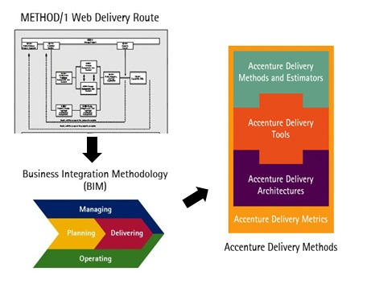

Accenture has placed a strong emphasis on methodology since the company’s beginning, and we continue to invest in ADM training and methodology development. As you can see in the graphic, our earlier methodologies have evolved into Accenture Delivery Methods.

In the 1970s, we developed METHOD/1 to support our Systems Integration work.

Over time, METHOD/1 evolved to include multiple routes for different types of systems development, including:

* Mainframe Client/Server
* Packaged
* Web
* Application Management

In the mid-90s, Accenture expanded beyond Systems Integration to include Business Integration. We developed Business Integration Methodology (BIM). This was a comprehensive approach for delivering “business capabilities”—people, process, and technology driven by strategy.

In the 2000s, Accenture's Methodology evolved to what we have today, Accenture Delivery Methods. In addition to the core Methods for Management, Strategy and Planning, Operations, and Development, Accenture has developed numerous specialty Methods to address a wide variety of work, including Oracle, Packaged Development, PeopleSoft, Retek, SAP, Siebel, and others.

Topic Summary

In this topic, you learned:

* About the many benefits of using ADM.
* About Global Policy 0011, Use of Accenture Delivery Methods, and the confidential nature of our methodology.
* How ADM fits into Accenture’s culture by taking a look at our company’s long history with methodology.
* How this methodology has underpinned our work on both Systems Integration and Business Integration engagements.

Now let’s look more closely at how the vision and strategy behind the Accenture Delivery Suite, of which ADM is one component, enables us to better serve our clients.

Topic Introduction

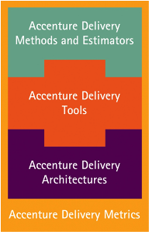

The Accenture Delivery Suite (ADS) provides a framework for reliably, quickly, and collaboratively delivering our solutions and services. ADS initiates a high degree of consistency and quality by offering a standard set of tested Methods, Estimators, Tools, Architectures, and Metrics that result in efficient, on-time delivery.

Through a disciplined approach to managing application development and application management work,  ADS promotes the successful implementation of our Global Delivery Model (GDM) across multiple sites, multiple workforces, and multiple cultures. By providing a common language in one global framework, ADS reduces the impact of cultural differences, decreases regional inconsistencies, and promotes our High Performance standards on client engagements around the world.

This topic will provide you with the information you need to facilitate your client engagements by using ADS.  You will learn how the multiple components of ADS, which are shown to the left, can contribute to your engagement’s and your own overall effectiveness and efficiency.

Accenture Delivery Suite Overview

ADS uses an integrated set of components to increase the reliability, quality, speed, and predictability of technology and outsourcing engagements.

Click on each component of the ADS graphic below for a detailed description of what it is.

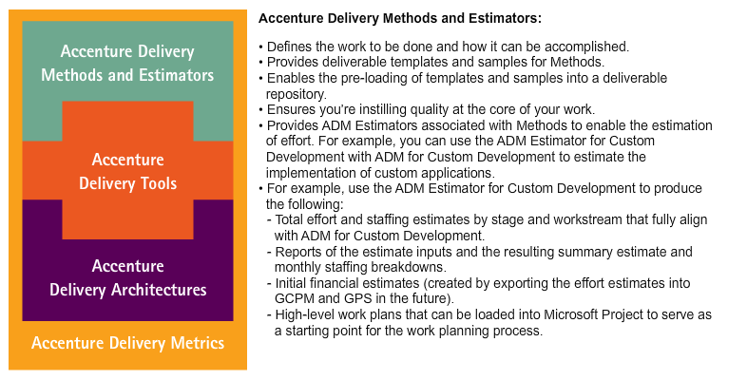

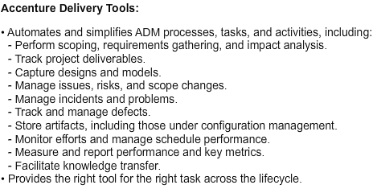

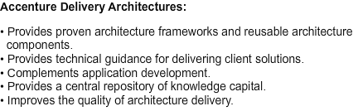

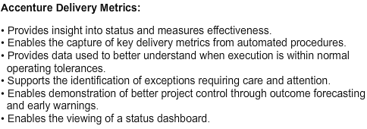

Checkpoint: ADS Component and Definition

Match the ADS component with its definition.

Click and drag each of the ADS components to its corresponding definition or function. Correct choices will remain; incorrect items will snap back into place.

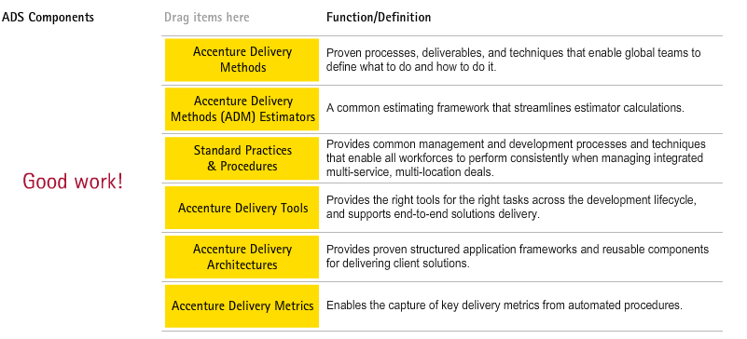

ADS Vision

Our vision for ADS is one in which project teams can provide Solutions on Accenture’s standard Methods, ADM Estimators, Tools, Architectures, and Metrics. That is, teams have access to a selection of Methods and estimating models, an integrated toolset (Accenture Delivery Tools), operating group and industry-specific deliverable samples, meaningful metrics, and the Accenture Delivery Architectures (ADA).

As projects use ADS, insights and best practices are harvested by project teams actively contributing back to ADS. Those best practices are incorporated into the ADS components, such as ADM and ADM Estimators, and made available to you, for your use. Users and experts can actively participate in virtual, collaborative networks, such as Communities of Practice.

The chart below illustrates the process Accenture uses to bring in and use best practices.

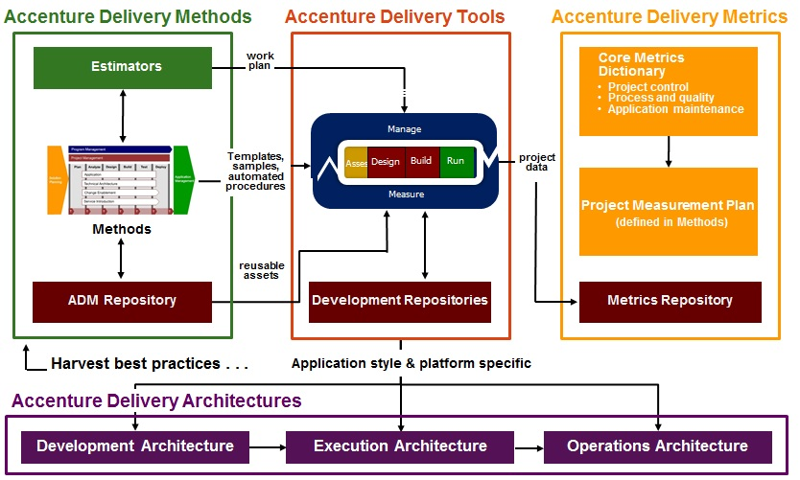

ADS Value

A methodology benefits an organization by capturing the organization’s best practices, providing a common vocabulary for the organization, and gaining from the repeatability of solution delivery processes. One of the most important functions of a methodology is to improve the effectiveness of planning, mobilizing and ultimately executing an engagement's solution.

But these organizational benefits and improvements can only be realized through the direct, tactical value that a methodology provides to the engagement teams who use it.

This tactical value can be measured in terms of how effectively that methodology meets the following objectives:

* Provide information to support the creation of proposals.
* Provide deliverable templates and job aids to assist in executing the work.
* Reduce the amount of time required to estimate, plan, and mobilize an engagement.
* Reduce an engagement’s risk profile by providing a high-quality, proven approach.
* Allow the engagement planner to change the scope, approach, or implementation details (defined in the standard methodology) to address a specific engagement context.

For more information on key benefits of a methodology and selling the Accenture Delivery Suite, go to the Selling collateral contained within ADS.Accenture.com.

[https://ads.accenture.com](https://ads.accenture.com/)

Next, examine how the methodology addresses these objectives and where you can go within ADM to address each of those objectives.

Added Value: Simplified Structure

ADS supports and enables industrialization through standard processes and practices and standard tools. You’ll learn more about standard practices, processes, and procedures later in this training.

In the meantime, we turn our attention back to the simple structure of ADM. ADM’s structure can be broken into three main levels. Level 1 is a high level planning chart and is mainly for executives. Level 2 gets more detailed and shows the activities in each workstream, which is important for project managers. Level 3 is the most detailed level of ADM. It shows the tasks associated with each activity, and is intended for practitioners.

Take a look at the chart below to become more familiar with each level of ADM.

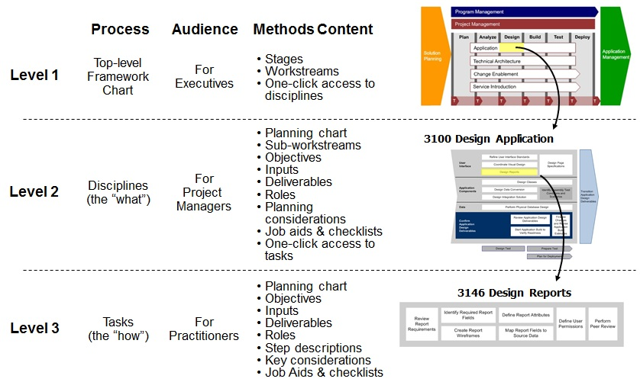

Now that you know how ADM adds value through its simplified structure, let’s take a look at how it adds value through its multiple-site delivery abilities.

Click [here](javascript:crse_showMultiPop('c020601_pop1.htm',%20610,%20520);) to read a chart that contains a listing of the most important ADM content terms in the glossary section.

Added Value: Multiple-site Delivery

All of our people, regardless of where they are located in the world, are required through Global Policy 0011 to use the same methodology. This means that communication is clearer because our people speak the same language with respect to building and maintaining systems, everyone understands the next steps and what to expect, and they all have a common frame of reference for thinking about how to build solutions and provide services. Using a common methodology gives us the ability to move work to the most capable and cost effective locations and/or workforces while still producing high quality deliverables and outcomes.

Accenture’s common methodology incorporates best practices such as:

* Formal, well documented transition points regardless of whether work is going to the team in the next cubicle or halfway around the world
* Clear guidelines for planning and managing distributed work
* Best locale: Moving work to the most suitable locations—which may be on-site for analysis and design but off-site for programming or testing—while achieving the same deliverables and outcomes
* Optimal delivery: Optimizing our management framework for our global workforces by allowing 24/7 delivery and management—anytime and anywhere—around the world

Accenture’s methodology promotes High Performance by focusing on quality creation and maintenance. Next, you will learn how the V-Model fits into our best practices by assuring quality standards are met at each stage of a project.

Added Value: Quality Focused V-Model

ADS infuses quality from the beginning. The V-Model, which incorporates the verification and validation of work completed at each stage, serves to make sure that each project level adheres to a common standard of high quality. The V-Model saves time and money in development while increasing the quality of the results and the reliability of delivery. Because quality is designed into the system rather than tested in, your adherence to the V-Model will contribute to a substantial decrease in the number of errors found in production after each release.

In addition, using the V-Model results in:

* Lower defect resolution cost since errors are detected earlier
* Reduction in the amount of rework
* Increased testing efficiency with an added focus on testing objectives
* Better informed scope definitions through requirements traceability
* Improved risk management

The model below illustrates how the V-Model promotes stage containment through validation, verification, and testing.

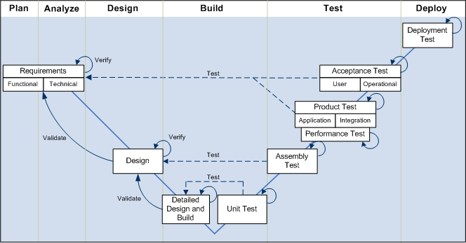

* **Validation:** Doing the right thing:
  + Checks that output deliverables satisfy the requirements specified in a previous stage’s input deliverables.
  + Ensures that the work product is in scope, contributes to the intended benefits, and does not have undesirable side effects.
  + Is performed by inspecting, simulating, or prototyping.
* **Verification:** Doing it the right way:
  + Checks that a deliverable is correctly derived and internally consistent.
  + Checks that output and the process conform to the standards.
  + Is performed by inspecting and reviewing.
* **Testing:** Right things working right:
  + Checks that a specification is properly implemented.
  + Is performed by executing the code.

Added Value: Estimating Model

ADM Estimators are part of ADM. That is, estimating models align directly with the corresponding Methods. The estimating model enables the process of determining the probable cost or effort of something, using historical information, experience, judgement, practice, analysis, and other techniques.

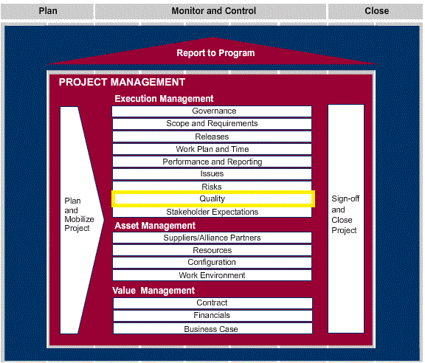

The integration of the Methods and ADM Estimators is the foundation of an effective Solution Planning process; Methods and ADM Estimators are linked at multiple levels.

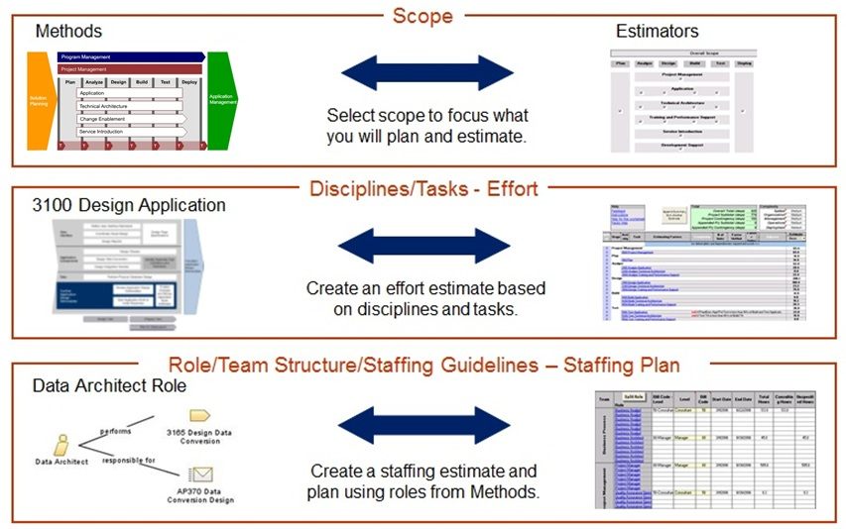

Added Value: Additional Items

ADM offers a variety of benefits in addition to those that you have just examined. Review the benefits of ADM below to gain a deeper understanding of its value.

* Accenture provides an integrated methodology that spans the entire engagement lifecycle. This is a clear strength that ties back to our strategy.
* ADM is integrated with the Accenture Delivery Tools:
  + Workbench enables basic process management
  + Deliverables in methodology are linked directly to the design repository
  + The Tools automate processes and deliverables defined through ADM
  + ADT provides you with the right tool for the right task across the lifecycle
* ADM is moving toward a 'module framework' in the development/implementation Methods to meet the following objectives:
  + Reinforce and align ADM with the use of standard, industrialized Tools
  + Align with standard practices and processes
  + Decrease the maintenance effort

Testimonial: ADS Value and Vision

This testimonial introduces you to the Accenture Delivery Suite, and explains how ADS provides Accenture delivery professionals with a set of tools to support project delivery from planning through measurement of delivery performance.

Topic Summary

In this topic, you learned:

* How ADS promotes the reliable delivery of quality products and services.
* How ADS can provide your engagement with a common global framework for communication, built-in quality standards at every level, and a process through which Accenture teams can contribute their insights to a virtual community.
* How ADS adds value to our client engagements.
* How the ADS components work together to provide a “whole” product that is greater than the sum of its parts.

Now, you will take a more in-depth look at the integrated components of ADS to explore how they contribute to high productivity by increasing the reliability, quality, speed, and predictability of technology and outsourcing engagements.

Topic Introduction

The Accenture Delivery Suite (ADS) vision is a consistent set of components working together. The overall user experience for the ADS components will be similar as they move from one engagement to the next. Project teams can deploy standard Methods, Tools, and Architectures, while Accenture harvests best practices from the field.



ADS promotes the successful implementation of our Global Delivery Model (GDM) through a disciplined approach to managing application development and application management work distributed across multiple sites, multiple workforces, and multiple cultures.

Note: For more information on the latest release of ADS and each ADS component, refer to [https://ADS.Accenture.com](https://ads.accenture.com/).

ADM Estimators Overview

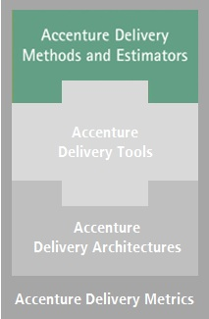

The ADM Estimators are part of the Accenture Delivery Methods. The ADM Estimators enable the process of determining the probable cost or effort of something, using historical information, experience, judgment, practice, analysis, and other techniques.

The ADM Estimators focus on realistic, accurate estimates. They encapsulate Accenture's estimating experience with delivery and maintenance engagements, and assist you in creating an estimate for the level of effort needed, as well as drive out cost estimates. The ADM Estimators create estimates that are fully aligned with ADM.

The ADM Estimators were designed and are updated by Accenture’s best resources on estimating. They are calibrated against actual Accenture engagements’ data to reflect the company’s best thinking for various estimating scenarios.

Almost every Accenture Delivery Method has a corresponding ADM Estimator. Where an Estimator exists for a Method, both the Method and Estimator are tightly integrated. This tight integration between Method and Estimator means that as you estimate, you can access and read descriptions about the activities, tasks, and deliverables corresponding to the work that you are developing an estimator for.



Based on your need, you can use the ADM Estimators to assist you in creating either a high-level or a detailed estimate.

The ADM Estimators have the following features:

* Extensive default parameters – to create a first-cut estimate quickly.
* Scope control and adjustment – to align the scope of the estimate to the project.
* Multi-site support – to adjust for the type and amount of work done in multiple geographic locations.
* Staffing – to generate staffing plans by roles, levels, and cost levels; Staffing Guidelines exist to guide you.
* Comparison – to benchmark estimates and to compare several of your own estimates.
* Append / Merge – to combine several project estimates together for an overall program view.
* Help – to guide you via extensive on-line help, process guides, factor definitions, glossaries, and estimating factor guidelines.
* Export to Microsoft Project – to create an initial work plan in Microsoft Project.
* Export to the [Global Pricing System Help Website](https://support.accenture.com/applications/SalesAndPricing/Pages/GlobalPricingSystem.aspx) (GPS) – to create an initial financial estimate. Note: The GPS is a web-based application made up of Price Optimizer, Deal Optimizer, and Management Reporting modules. GPS replaces the Global Consulting Pricing Model (GCPM) application.

There are several important add-ons that you will find helpful. Click on the areas in the graphic below to learn more.

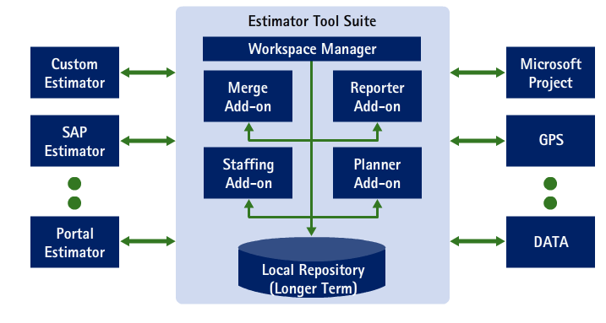

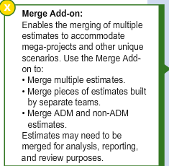

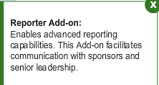

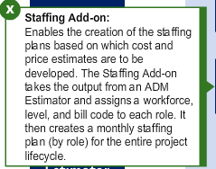

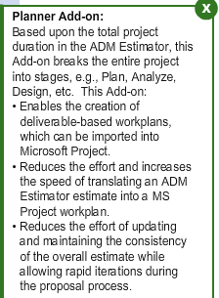

Testimonial: When to Use ADM

This testimonial explains the importance of Global Policy 0011.

Accenture Delivery Tools Overview

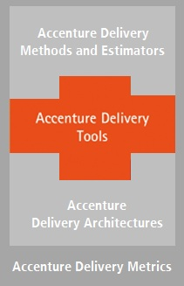Accenture Delivery Tools (ADT) is a component of the Accenture Delivery Suite. ADT provides Tools for delivering our solutions and services regardless of the type of work being delivered (SI, Outsourcing, combined, etc.). ADT allows us to mobilize and deliver reliably, quickly, and collaboratively.

ADT provides Tools that address every phase of work (Plan, Analyze, Design, Build, Test, and Deploy). ADT provides Tools that are designed to create deliverables within each project phase and to interact with each other through the project lifecycle. For example, ADT covers the system development lifecycle from requirements gathering through system test and implementation, and also provides capabilities for change management and configuration management.

The Tools of ADT offer market-leading functionality from established vendors, as well as “home-grown”, or Accenture-developed Tools. For example, Microsoft Project / Microsoft Project Server is part of the ADT toolset and is the standard Tool used for work plan development and maintenance.

ADT supports your many, varied tasks and activities. There are Tools within the toolset to support requirements management, process modeling, design, coding, testing, and deployment, and include an integrated repository. The Tools also enable program and project management, and metrics collection for all types of work. ADT enables the capture and reporting of required Accenture Delivery Metrics.

The Tools enable consistency among engagements. The same Tools can be used for work performed on-site and in delivery centers, for custom work (e.g., Java, .NET) and packaged work (e.g., SAP, Oracle), and for Outsourcing and Systems Integration.

**End-to-End Enablement:**  
As mentioned, there are Accenture Delivery Tools to support your engagement across the entire engagement lifecycle, and at any single stage during the lifecycle.

This full end-to-end enablement supports ADS’ focus on industrialization. ADT industrializes the way we deliver end-to-end quality solutions and services – normalizing and deploying standard tools and processes across delivery, driving improvement, and reducing costs for all types of work.

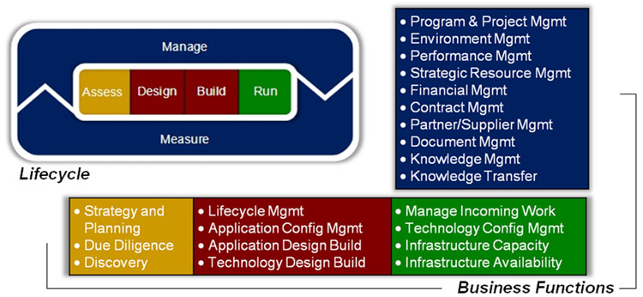

ADT provides Tools that fit the stage you’re in and the task you’re working on across the lifecycle of your engagement. They drive end-to-end solutions, starting from the first day.

ADT: Included Tools

ADT provides Tools for:

* Storing artifacts (such as templates, samples, etc.)
* Tracking project measures and metrics
* Capturing and managing requirements
* Building process models
* Performing detailed analysis and design activities
* Transforming design artifacts into build components
* Testing applications
* Managing deployment of code and applications to testing and production environments

A sampling of Tools that are available is listed in the graphic below. Click on each area in the graphic to view the sample Tools. Note that this shows you a "snapshot" in time. Leading edge Tools are incorporated into the ADT toolset continually. To see the most recent listing of Tools, go to ADS.accenture.com.

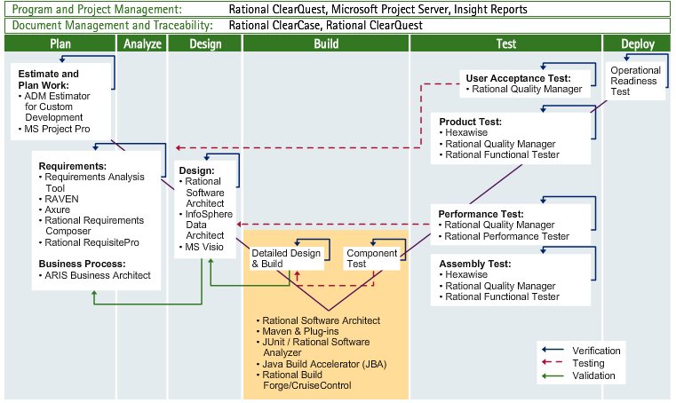

ADT: Integration to ADS

The Accenture Delivery Tools pulls the Accenture Delivery Suite (ADS) assets together. It:

* Provides a repository for all ADM templates, samples, and output documentation.
* Provides a platform for automation for managing your engagement (logging and tracking risks, issues, scope changes, defects, incidents, changes, etc.).
* Facilitates the capture of the Accenture Delivery Metrics.
* Provides coverage for the complete application development lifecycle, from planning through testing, and enables traceability across lifecycle stages to ensure deliverable integrity.

The Tools can be used along with the Accenture Delivery Architectures. They can be used across all project types. Usage guidelines are provided for select types, including Java, .NET, SAP, Oracle, and Siebel.

ADT: The Benefits of ADT

The benefits of ADT include:

|  |  |
| --- | --- |
| **Benefit** | **Advantage** |
| **Speed** | Ability **to get up and running with minimal disruption** to existing operations. **Saves time and money** by using AMT Deployment. |
| **Proven engagement settings** | **Increased productivity** generated by using out-of-the box, **ready to use standard tools** can lead to up to a 2 percent increase in the engagement margin.Globally-funded: no costs for licensing/hardware, hosting, training creation from scratch, and support services. |
| **Automation of development lifecycle and general workflow** | **Tailored** to specific tasks and roles. **Reduces** **risk** of costly rework and human error.  **Full project lifecycle traceability** from requirements gathering through design, development, testing and deployment. |
| **Team integration** | **Effective** **collaboration** of geographically distributed and multi-vendor teams through standard tools and central repositories. **Minimizes transition time** from on-site to off-site teams. |
| **Repeatable, predictable, and scalable tools and processes** | **Common toolset** improves quality and productivity.  Provides a consistent way to manage and deliver our projects across Consulting, Outsourcing, and Delivery Centers. |
| **Transparency** | **One-stop-shop for Project Managers**,  including status/tracking of deliverables, percent complete, resource assignments, peer reviews, testing, defects, risks and issues, project tasks, etc.  **Real-time project metrics enable fast and educated decision making.** |
| **Improves quality** | **Standardization is fundamental** to CMMI accreditation and industrialization objectives of Managed Delivery. |

ADT: Detailed Toolset Descriptions

A sampling of Tools that are available is listed in the graphic below. Click on each area in the graphic to view the sample Tools. Note that this shows you a “snapshot” in time. Leading edge Tools are incorporated into the ADT toolset continually. To see the most recent listing of Tools, go to ADS.accenture.com.

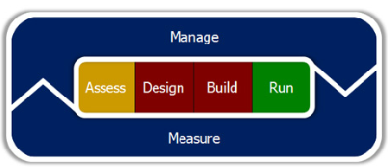

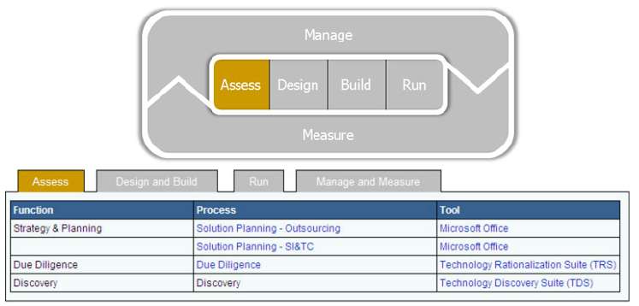

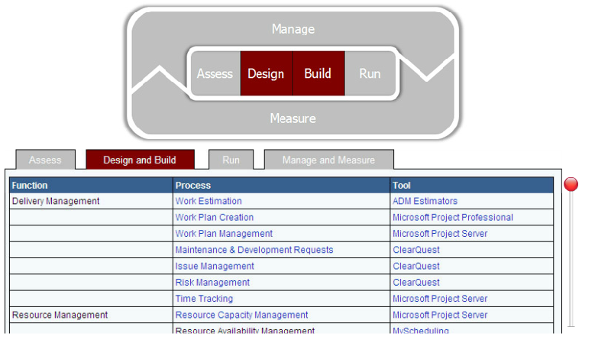

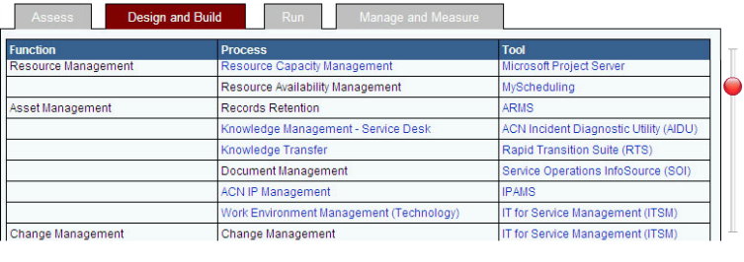

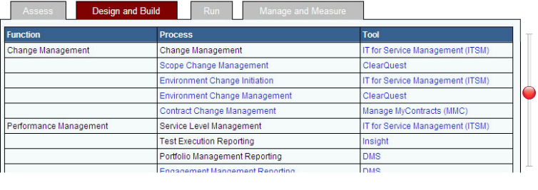

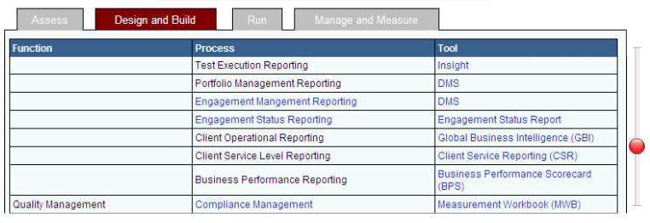

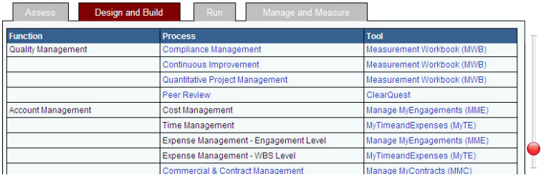

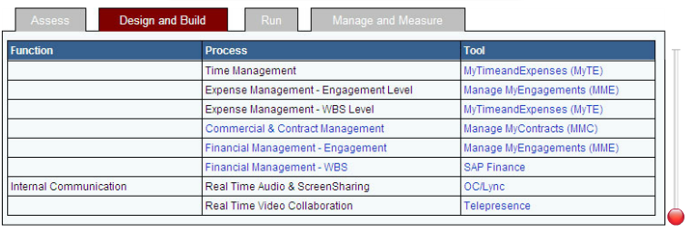

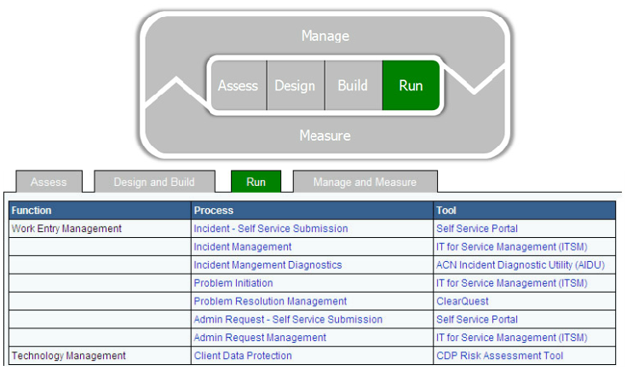

Checkpoint: Benefits of ADT

Match up the high-level ADT benefit with the appropriate detail benefit.

Click and drag each of the ADT detail benefits to its corresponding high-level benefit. Correct choices will remain; incorrect items will snap back into place.

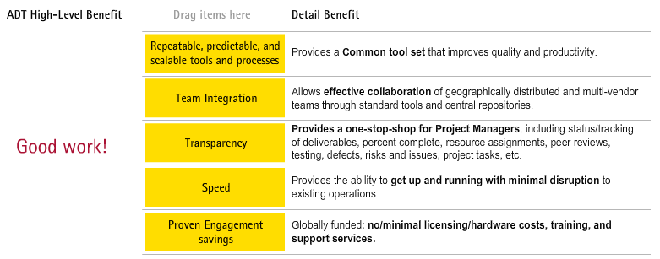

Common Architecture Issues

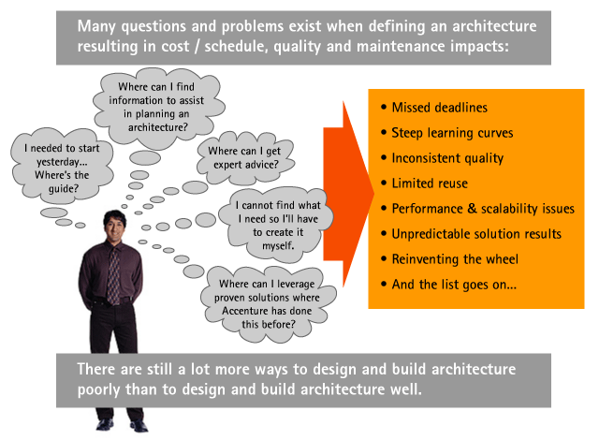

Accenture Delivery Architectures

Accenture Delivery Architectures (ADA) provides a prescriptive approach to guide architects and developers in delivering client solutions through proven practices, starter kit reference applications, proven application frameworks and reusable components. ADA enables technical architects to leverage proven, repeatable architectural solutions.

The main focus of ADA is to establish a consistent framework to conceptualize and deliver platform-specific architectures.

ADA provides an integrated view of architecture through rationalizing and more clearly communicating our assets and specialty groups.

ADA enables project delivery by supporting both:

* A top-down approach
* Detailed answers to bottom-up questions

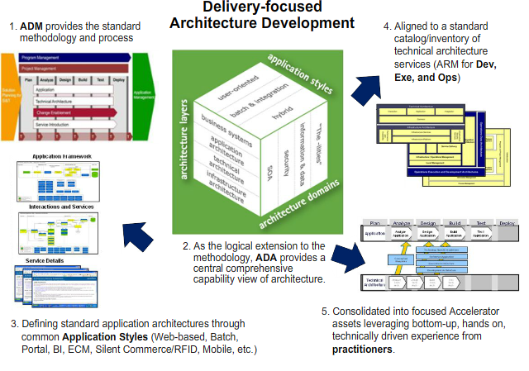

ADA: What is ADA?

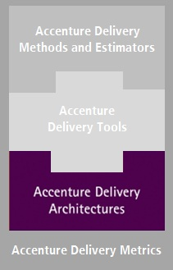

Accenture Delivery Architectures (ADA) provides the Technical Architecture component of the Accenture Delivery Suite (ADS). ADA has a significant portfolio of conceptual design material in the form of reusable architecture blueprints.

ADA is a resource for projects that want to find an appropriate Architecture for the system they are delivering. ADA provides proven structured application frameworks and reusable components to guide developers on the correct way to build a robust netcentric application. Given the realities of the diversity in platform standards, vendor offerings, and client preference to each of these concerns, ADA focuses on establishing a consistent framework within which our teams conceptualize and deliver the Technical and Application Architectures for an engagement. It also focuses on providing the architecture knowledge capital and assets required to support successful delivery of projects.

Accenture Delivery Architectures:

* **Provides a central repository of knowledge capital.** ADA provides proven application frameworks, patterns, practices, technical execution services, and reusable artifacts to deliver Application Architecture for common Application Styles.
* **Improves the quality of architecture delivery.** ADA harvests, documents, publishes, and collaborates on proven architecture patterns, practices, and delivery approaches firm-wide. Using ADA’s predefined Architectures increases project organization.
* **Reduces project risk.**1) Using ADA on a project reduces risk and workdays associated with custom implementations. 2) Risk and workdays are also decreased with the re-use of proven Architecture frameworks. 3) ADA Architecture principles help stabilize the project lifecycle and point out critical areas of focus. 4) ADA’s integration with ADS improves relevance with technology domains and increases uptake / usability.
* **Lowers project costs:** Clients prefer less proprietary, lower cost software. ADA addresses this desire by 1) leveraging open standards and enterprise-ready open source software, and 2) using proven Architecture frameworks, which means teams can spend less time designing and developing.
* **Increases the speed and consistency of development.**ADA is built on reusable Architectures straight from real-world development, testing, and trials.

Accenture Delivery Architectures (ADA) provides not only the framework, but also the architecture knowledge capital, expertise, and assets that projects need to successfully deliver solutions and services.

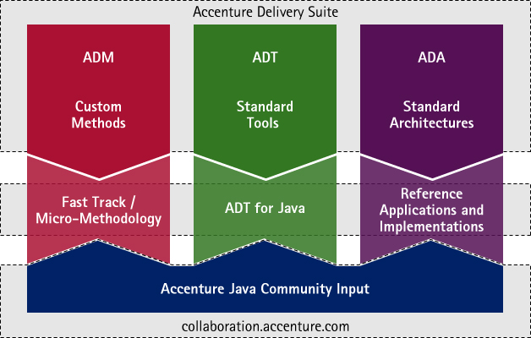

ADA: Overview

This graphic illustrates how Application Styles, Delivery Architectures and Architecture Domains are interconnected.

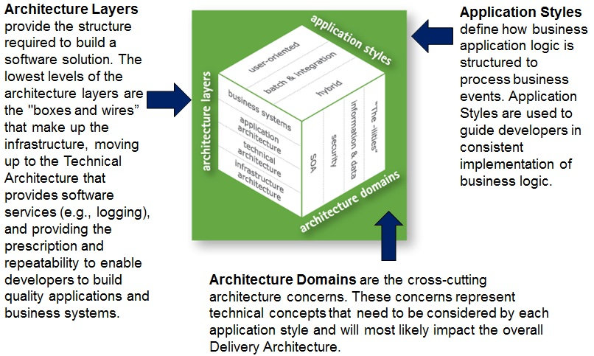

ADA: Target Audience

ADA’s real audience is any technology architect and developer that will be in an architecture planning, designing, implementing, or operating role. ADA contains a significant amount of valuable information related to architecture frameworks.

**Architects:**

* Leverage proven, repeatable architectural solutions
* Help design Application Style(s) required for custom solutions
* Provide a framework for selecting required execution services
* Help recommended pre-integrated solutions, such as General and Reusable Netcentric Delivery Solution (GRNDS) and Access Control Agent .Net technology (ACA.NET)
* Standardize quality assurances processes

**Developers:**

* Help explain the overall architecture picture
* Educate by providing How To documents, guides, or links to external/internal sources
* Identify the custom application artifacts to be created
* Provide best practices that are used in a typical Solutions Development Lifecycle (SDLC)
* Present a forum to collaborate and contribute best practices

**The project as a whole:**

* Reduces the effort associated with architecture planning, design, and implementation
* Helps build solutions on proven architectures
* Provides a framework and template “site” for pushing architecture materials to the development team
* Offers the Developer workbench concept where content is organized by roles on the project

Checkpoint: ADA Terms and Definitions

Match up the high-level ADA term with the appropriate definition.

Click and drag each of the ADA terms to its corresponding definition. Correct choices will remain; incorrect items will snap back into place.

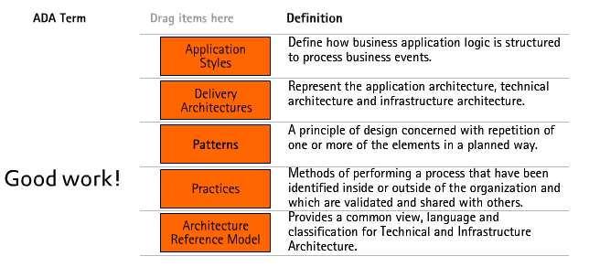

Accenture Delivery Metrics: Introduction

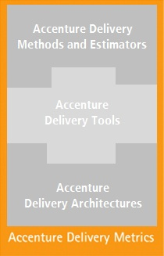As part of the Accenture Delivery Suite, the goal for Accenture Delivery Metrics is to help engagements improve delivery performance, and in the long term, support the improvement of key delivery processes. Accenture Delivery Metrics enables defined, consistent, and quantifiable measures of delivery performance.

**Program Goals**

* Drive a consistent set of core delivery Metrics across Accenture
* Improve delivery performance and support the improvement of key delivery processes
* Enable and encourage the uptake and consistent use of a core set of common Metrics
* Focus on measuring the priority processes that underpin predictable delivery outcomes
* Accelerate data collection and organization reporting by leveraging existing successful Metrics programs

**Benefits**

Using Accenture Delivery Metrics will enable engagements and programs to better understand when execution is within normal operating tolerances and to proactively identify exceptions requiring care and attention.

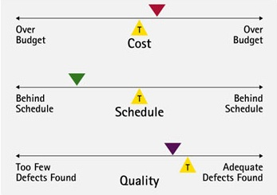A consistent approach to quantitative project management through standard metrics provides clear benefits to all stakeholders, including:

* Transparency of status supported by earned value reporting
* Better control through outcome forecasting and early warnings
* Lower overall costs to clients through higher productivity and more predictable outcomes
* Consistency in the approach to quantitative project management through standard Metrics
* Greater clarity when execution is within normal operating tolerances and when exceptions exist that require care and attention

**Accenture Delivery Metrics Set**

The Accenture Delivery Metrics list is based on the intersecting set of priority metrics from existing programs. The intent is to drive consistent use of this priority sub-set across all Accenture organizations.

**Enabling a Firm-wide Metrics Analysis Program**

The Accenture Delivery Metrics program provides projects with timely feedback on the progress of the project. The Metrics program has demonstrable traction across Operating Groups and Growth Platforms. The project teams make monthly Metrics contributions and Metrics reports are created more quickly and are available at multiple levels – from project level through to Senior Executive level

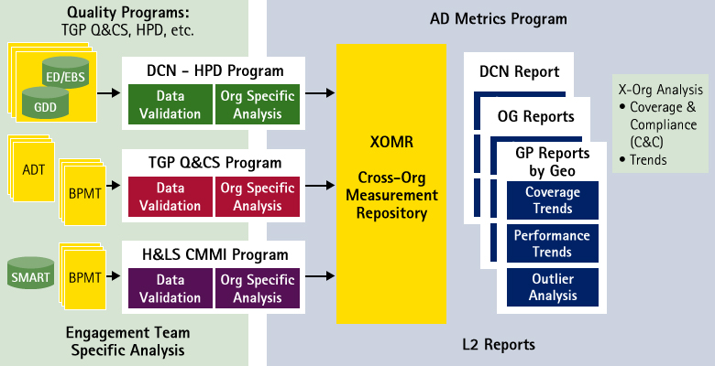

Accenture Delivery Metrics: Overview

Accenture Delivery Metrics have been defined that:

* Underpin the Priority Processes for predictable delivery outcomes and Capability Maturity Model Integration (CMMI)
* Are directly valuable to engagement management
* Enable transparency of engagement process and status for the organization

**Standard Core Metrics**

All Accenture Delivery Metrics are derived from basic project measures and are grouped into one of three categories – Control Metrics, Process and Quality Metrics, and Application Maintenance Metrics.

|  |  |  |
| --- | --- | --- |
| **Metrics Group** | **Priority Processes** | **Key Measures** |
| Control | * Effort/schedule monitoring * Deliverable timeliness | * Budget, ATD, ETC, Earned Value * Planned/Actual Start & End dates * Deliverables due/transitioned |
| Process & Quality | * Peer Reviews * Change Control Management * Defect containment | * # Change requests and efforts * # Defects found/missed per stage * # Review, test, rework effort |
| Application Maintenance | * SLA Compliance * Resolution Timer Performance * Backlog Monitoring | * # SLAs met/missed * # On time resolutions * Average backlog |

These three Metrics Groups underpin the priority delivery processes that drive predictable delivery outcomes.The Accenture Core Metrics most appropriate for your project depends upon your project type.

Accenture Delivery Metrics: Scope

Accenture Delivery Metrics are derived from basic project measures:

* The Core Metrics are derived from a small number of basic measures that any well-run project should have.
* The Conditional Metrics typically require an additional level of process/planning maturity.

It is important to consider that:

* Most Metrics are already in use to some extent by existing programs.
* The associated processes are key to CMMI certification.
* Managing down the Cost of Quality/Poor Quality remains an important objective.

The scope of the Accenture Delivery Metrics program encompasses both an asset perspective as well as an operations perspective.

From an asset perspective, the Accenture Delivery Metrics program is focused on driving a set of mandatory Metrics through existing Metrics programs. This is done by incorporating these Metrics into key Accenture Delivery Suite assets:

* **ADM Deliverables** – Update and maintain MG111 – Measurement Plan. MG111 is one of the key management plans for projects to adopt.
* **ADM Procedures Assets**– Incorporate links where applicable with process documentations – e.g., Configuration Management process would include a reference to CR Impact.
* **ADT Assets**– Work with the Tools Team to incorporate appropriate definitions into the toolsets such that the core Accenture Delivery Metrics are generated as part of performing the work activities.

Accenture Delivery Metrics: Integration with ADS

This graphic illustrates how ADM incorporates ADT and Accenture Delivery Metrics.

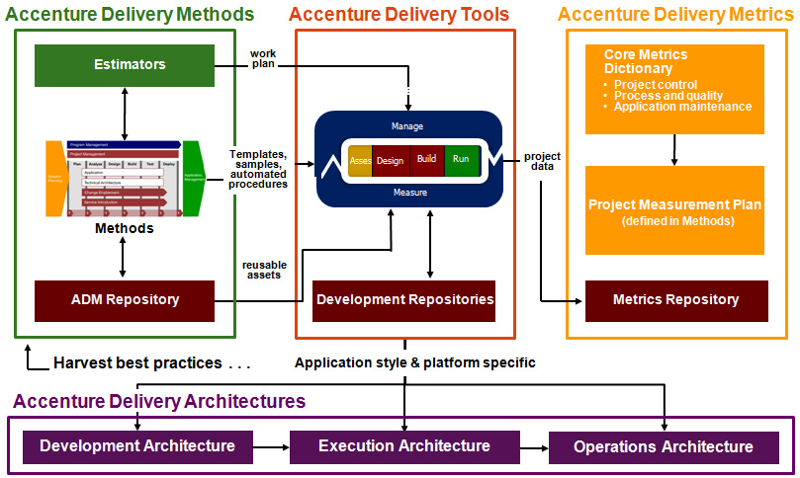

Checkpoint: Accenture Delivery Metrics

Identify which Core Metrics Group measures each Priority Process. Click on the appropriate cell to assign the appropriate column and click “Submit” when complete.

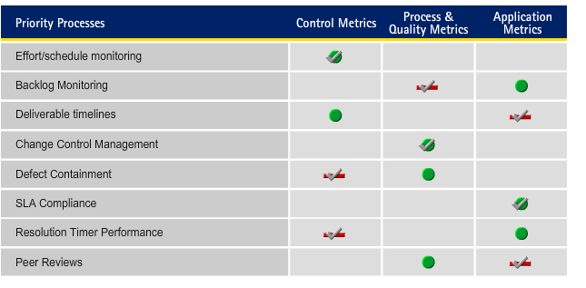

Topic Summary

In this topic, you learned:

* About the components of ADS, including ADM, ADT, ADA, and Metrics.
* How all components of ADS – ADM, ADT, ADA, and Metrics – integrate tightly.
* How the integrated components of ADS contribute to high productivity by increasing the reliability, quality, speed, and predictability of technology and outsourcing engagements.

Now, you will take a more in-depth look at the overall structure of ADM, with detailed examination of some of the specific processes and deliverables that help Accenture to deliver consistently excellent solutions and services.

Topic Introduction

The purpose of this topic is to provide an overview of the ADM structure and scope. In addition, this topic will provide best practice navigation information and helpful tips, including specific details about processes, work products, and roles.

ADM Scope

Accenture Delivery Methods aims to standardize on a common set of delivery management functions that are most common on Design, Build, and Run engagements. It is designed to support various types of work, including System Integration, Application Development, Application Management, Infrastructure Outsourcing, and Technology Consulting.

ADM is Accenture’s methodology for creating and delivering:

* Effective, consistent, and lower-cost client solutions.
* A comprehensive set of Methods that supports multiple types of work (e.g., custom development, package implementations, and outsourcing).
* ADM provides a framework to utilize on client engagements.

Three Tier Approach

The Methods provide a standard three-level framework that can be drilled down. Within that framework are standard inputs, outputs, and roles associated with each process or task. From this common starting point, teams can tailor the processes and deliverables to meet their specific needs.

This graphic illustrates the three levels of the methodology:

Level 1 – Intended for the executives/project phases perspectives  
Level 2 – Intended for the project manager/planner – i.e., the “what”  
Level 3 – Intended for the practitioner – i.e., the “how”



Testimonial: Three Tier Approach

This testimonial explains how the three tier approach makes increasing client understanding and confidence in Accenture's delivery strategy much easier.

ADM Framework: Overview

This overview explains:

* The framework for the methodology
* The main content types and how they relate to each other
* The supplemental content types available to help you

This Method is structured as a matrix of phases and workstreams, which will be reviewed in the next few pages.

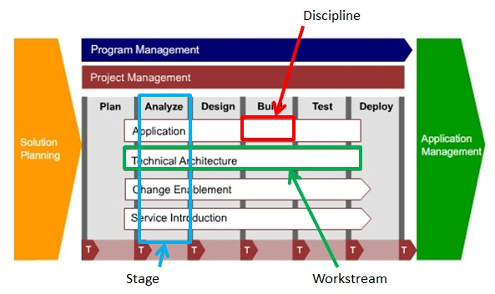

ADM Framework: Stages of Work

The vertical bars are the stages of work within a project.

* **Plan:** Define Solution Blueprint and organize the project (determine the business goals, scope, and high-level requirements of the project).
* **Analyze:** Gather, identify, analyze, and manage the requirements. If relevant, evaluate packaged software and select technology infrastructure components. Determine environmental and process needs to support the new capability/service.
* **Design:** Design the solution, such as the application(s), technical architecture, technical infrastructure, and/or application training.
* **Build:** Develop the solution, such as the application(s), technical architecture, technical infrastructure, and/or application training.
* **Test:** Test components built by all workstreams and validate the solution with users.
* **Deploy:** Roll out the solution, such as the application, technical architecture, technical infrastructure, and training to the organization.

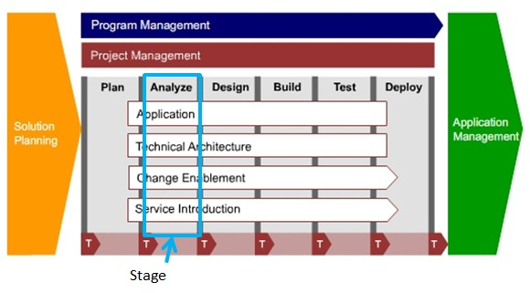

ADM Framework: Workstreams

The horizontal bars are workstreams, defined as a domain or area of work. Workstreams group together tasks usually performed by a team of people with related skill sets.

* **Project Management:** Determine the project work effort and resources; manage risks, issues, quality, scope, and finances; create and maintain project standards; control project work; measure progress; and report status. Project management is shown separately because it spans the entire lifecycle of the project, and has many of the same activities performed iteratively.
* **Application:** Develop the systems to support the solution. This includes the user interface, content, business logic, and data.
* **Technical Architecture:** Develop the execution environment, development environment, and operations environment, as defined today in Accenture Delivery Architectures (Knowledge Exchange).
* **Change Enablement:** Is critical for ensuring successful adoption of the change for our sponsoring organization. All systems implementation projects should have a change enablement component that includes the necessary change management, organization transformation, training and performance support, and leadership activities.
* **Service Introduction:** Validate the operability of the application while determining what the application management unit needs to do to be ready to support the application.

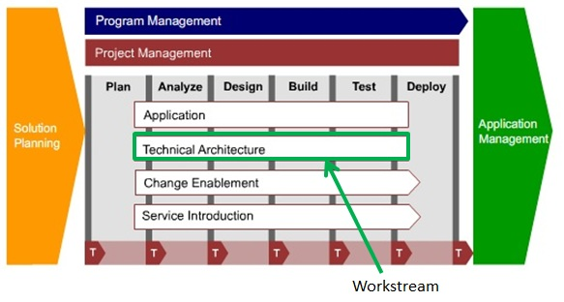

ADM Framework: Activity

This is a screenshot from ADM. In the actual ADM, to open an activity, click on the appropriate intersection.

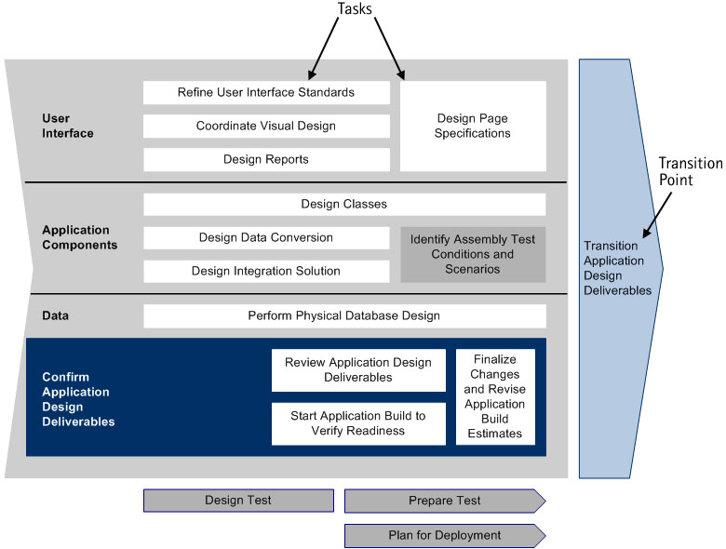

Clicking on any of the boxes on the diagram opens a task, the lowest process level in the Methods. Gray boxes indicate tasks that involve members of this team but are the responsibility of another team. For example, Plan for Deployment needs to leverage application designers, but is the responsibility of the Deployment Team.

Between each activity in each workstream are transition points. A transition point represents an interface and/or handoff between two teams on a project. At a transition point, project deliverables (requirements, design documents, code, etc.) are transitioned from one team to another. The main purposes of the transition points are to confirm the quality of deliverables being transitioned and to foster effective communication between the "sending" and "receiving" teams to reduce project risks.

The framework is shown as a simple matrix. It is not meant to show time dependencies between the different workstreams. For example, all analyze activities (Analyze Application, Analyze Technical Architecture, Analyze Change Enablement, and Analyze Service Introduction) may not happen simultaneously; each workstream may have interrelated dependencies that may require some activities to precede others, while others to be performed in parallel. However, all tasks are initiated from the Plan activity.

Similarly, the simplicity of the framework does not graphically depict the likely iterations that will take place within the project. Iteration planning is done as part of the Plan activity.

ADM Primary Methodology Content Types

There are three key types of content in the methodology:

* **Processes:** What you need to do
* **Work Products:** What you need to produce
* **Roles:** Who needs to do it

These three content types all reference each other to form the foundation of the Methods.

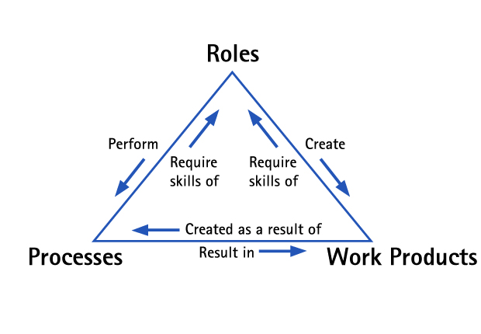

ADM: Processes

In ADM, there are two levels of process documents:

* Activities are large units of work with a single major outcome. For example, the Design Application activity results in the Application Design deliverables. Activities are composed of tasks.
* Tasks are smaller units of work that are performed by one individual or team to create a single primary outcome. Tasks, in turn, are composed of steps.

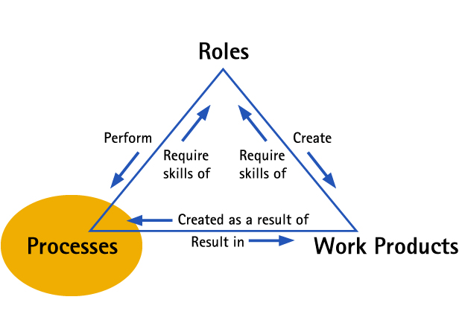

ADM Processes: Activities

Activity documents are written primarily for the manager or team lead of a project. This graphic shows the approximate timing relationship between activities in ADM for Custom Development. The actual timing and dependency relationship may vary for each project.

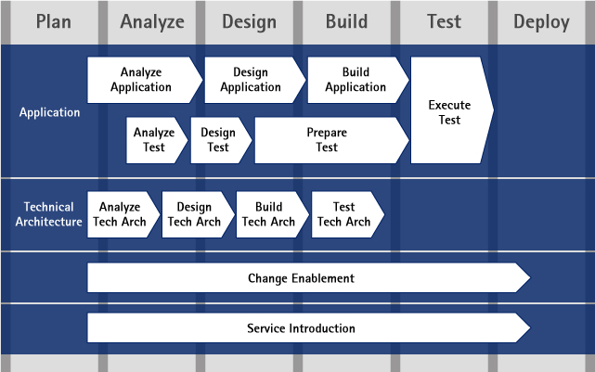

Important Note: The order of the following information is not based on importance. To make the most of the ADM website, it is important for you to understand where the information you need is. Having an understanding of what each section contains will help you to quickly access what you need and make ADM a very powerful tool to use in your daily work. Please make sure to pay close attention to how content is organized on ADM, as it will help you later to leverage the right information

In complex activities, the tasks may be organized into sub-workstreams, based on the skills needed to perform the tasks. For example, the Design Application activity contains three sub-workstreams: User Interface, Application Components, and Data.

Each activity is described by a discipline and a capability pattern.

**Disciplines**

A discipline is the main page and entry point for an activity. It provides a planning chart schematic to show the tasks within the activity and their dependency relationships. It also contains links to:

* The capability pattern (described below).
* A list of tasks associated with the activity.

**Capability Patterns**

A capability pattern provides a more detailed look at the activity and its tasks. Each capability pattern page contains the following information:

* Main Description
  + Purpose: This includes the activity planning chart identical to the graphic associated with the discipline. It also lists the activity’s principle objectives and outcomes.
  + Work Product Usage: This lists the work products and details if they are mandatory or optional and if they are a key input or a key output for the activity.
  + Work Product Flow view: This includes a schematic that shows information on the flow of and the dependencies between work products throughout the lifecycle of a project.
* Illustrations
  + This includes information about reusable assets that can be used to complete the activity.
* Key Considerations
  + This includes a description of how the activity is related to other workstreams.
  + These explain the dependencies between this activity and other activities or workstreams. These also include the key issues to consider for planning, managing, staffing, and successfully completing the activity.
* Relationships
  + This lists the tasks that need to be completed to complete the activity.
* More Information
  + This lists checklists, guidelines, and other resources that are relevant to the activity.

ADM Processes: Tasks

Task documents are written for the team member executing the work. In each task, you will find the following information:

* Purpose: This describes the objectives and intended outcomes of the task. This also includes a planning chart that illustrates how work should be conducted.
* Roles: These describe the skill sets required to execute (primary performer), assist or review the work (additional performers).
* Inputs and Outputs: These show the inputs and outputs of the task, grouped by which work products are necessary (mandatory) and which are useful but not essential (optional).
* Steps: These provide an explanation for each step in a task's planning chart.
* Illustrations: This includes information about reusable assets that can be used to complete the task.
* Key Considerations: These include the key issues to consider for planning, managing, and successfully completing the task.
* More Information: This lists checklists, guidelines, and other resources that are relevant to the task.

ADM Work Products

For each work product you can access detailed information and templates/samples on work product-artifact or work product-deliverable pages.

Work product pages provide you with the following types of information:

* Description
* Illustrations by template and/or sample
* Key considerations
* Relationship to roles and tasks

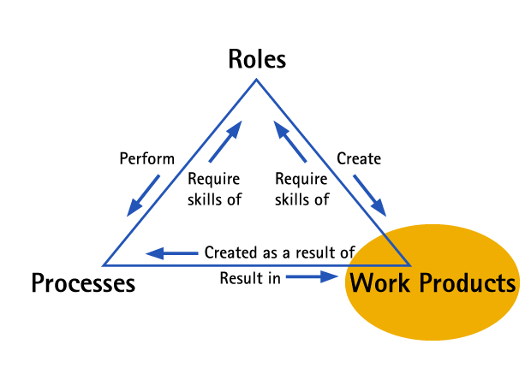

ADM: Transition Points

As previously mentioned, transition points are a special kind of task dedicated to transitioning already validated deliverables to the next team responsible for continuing the project. For example, T3199 Transition Application Design Deliverables provides you with information on what the Design Team needs to transition to the Build Team, and what the critical outcomes should be.

The following are defined for each transition task:

* Purpose (with a goals list and schematic)
* Relationship (with Roles of primary performer)
* Relationship (with outputs/deliverables)
* Steps description
* Illustrations (with templates and /or samples documents and reusable assets)
* More information (supporting materials as reference for executing the task)

The main purposes of the transition points are to:

* Ensure the quality of deliverables being transitioned
* Foster effective communication between the sending and receiving teams

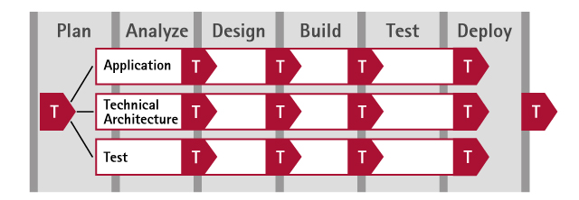

ADM: Roles

Roles are the skill sets needed to complete a task. A person on a team may have one or more roles on the project. Similarly, more than one person on a team may share a role.

There are two types of roles in the methodology:

* Primary Performers: These are roles that are primarily responsible for completing a task or work product
* Additional Performers: These are resources who assist in completing a task or work product by reviewing the work of or providing the expertise to the primary performers

Each role description in ADM provides the following information:

* Tasks and deliverables (work products) the role is responsible for
* Tasks and deliverables (work products) the role participates in
* Description of the role's responsibilities
* Skills required for staffing the role
* Additional resources for the role

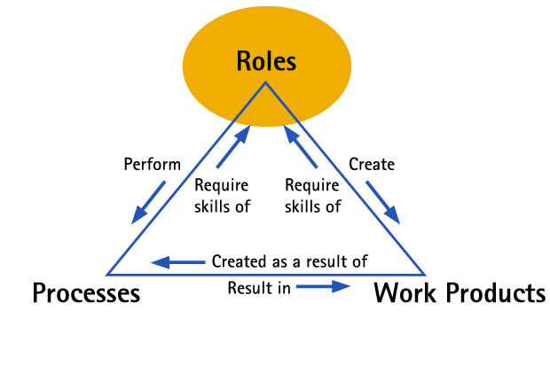

Checkpoint: ADM Benefits

Match up the high level ADM benefit with the appropriate detail benefit.

Click and drag each of the 3 Tiers or Framework Elements to its corresponding Description. Correct choices will remain; incorrect items will snap back into place.

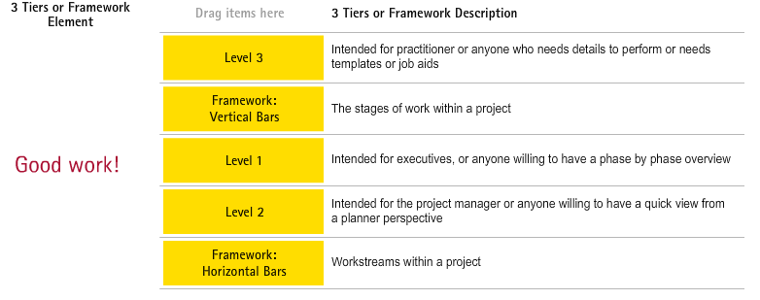

ADM: Supplemental Content

In addition to the main object types, the methodology provides additional assistance for users in the form of guidance: guidelines, checklists, external resources (including practices), and samples/templates.

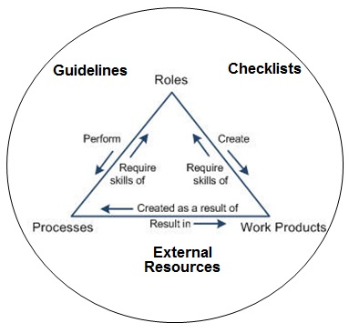

**Guidelines**

Guidelines and concepts (a.k.a. job aids) provide additional guidance for completing a task or work product.

They are housed in the Guidance tab in the Navigation panel and contain the following information:

* **Main Description:** This is the guidelines’ content and contains all of the information and instructions needed.
* **Relationships:** This lists all related documents within the Method.
* **More Information:** This is a list of additional references both within the Method and external to it.

**Checklists**

Checklists provide tools for quick quality checks at key points in the process. Each checklist comes with an attachment, allowing you to easily download a copy of a checklist, customize it as necessary for your project, complete it, and store it with your project deliverables.

All checklists are housed in the Guidance tab in the Navigation panel and contain the following information:

* **Main Description:** This describes what the checklist aims to accomplish and when to use it.
* **Check Items:** These are the items to check off while completing the checklist, separated by general subject areas.
* **Relationships:** This lists all related documents within the Method.
* **More Information:** This is a list of additional references both within the Method and external to it.

**ADS Practices**

ADS Practices are common management and development processes used across all types of work.

All ADS Practices referenced in a methodology are listed in the Guidance tab in the Navigation panel and contain the following information:

* **Main Description:** This describes what the practice aims to accomplish and when to use it. This section also provides a link to the specific practice on the ADS Practices site.
* **Relationships:** This lists all related pages within the Method.

**Samples and Templates**

For some Methods, work product samples and templates are stored outside of the Methods in a separate repository. This separation from the Methods enables the addition and update of samples when received, independent of the release cycle of the Methods.

Other Methods continue to have the samples and templates embedded inside the Methods.

ADM: Process and Work Product IDs

In ADM, every activity, task, and document has a predefined ID. This ID code is not to be changed or customized because we want engagement teams to refer to activities, tasks, and documents consistently across the company. Please note that this means you can often also use the ID number instead of the full name of the activity, task, or work product.

* Processes have a four-digit numeric identifier
* Work products have a five-character alphanumeric identifier

Process IDs take the form:

|  |  |
| --- | --- |
| https://mylearning-products.accenture.com/SEF_ADMv3/ADF_ADM/m01/images/010518.gif | First digit. The stage of the activity; for example, all activities in the Design stage start with the number 3   Second digit. The workstream of the activity; for example, all activities in the Application workstream have a second digit of 1   Third and fourth digits. The sequence of the process—"00" indicates a discipline/activity; for example, the Design Application activity has an ID of 3100; Design Classes, a task in Design Application activity, has the ID 3153 |

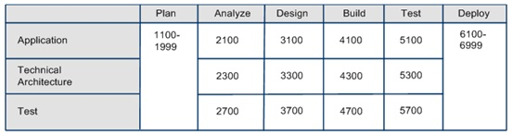

ADM: Work Product IDs

Each work product has a five-character alphanumeric identifier:

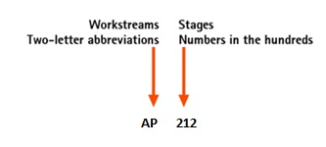

The first two letters are an abbreviation. An abbreviation for the workstream that is primarily responsible for creating the deliverable; for example, all application work products begin with "AP". The numbers indicate the sequence of deliverables relative to other deliverables.

Testing deliverables, including test-planning deliverables, are given their own ID prefix of TE; for example, the Test Approach deliverable has the ID TE582. It allows test planners and testers to find deliverables specific to their specialty quickly.

Accessing ADM

Here are the main ways to access ADM:

* From ADS.accenture.com > Methods, Tools and More > Methods
* Local desktop copy, which you have downloaded from the ADM site.
  + Downloaded Method content is automatically updated with ADM udpates.
  + Note: Remember that ADM is Accenture Proprietary material. Its use must comply with Accenture polices on the Use of Accenture Delivery Methods.
* Note: ADS.accenture.com is also available from the Accenture portal via My Work > Accenture Delivery Suite.

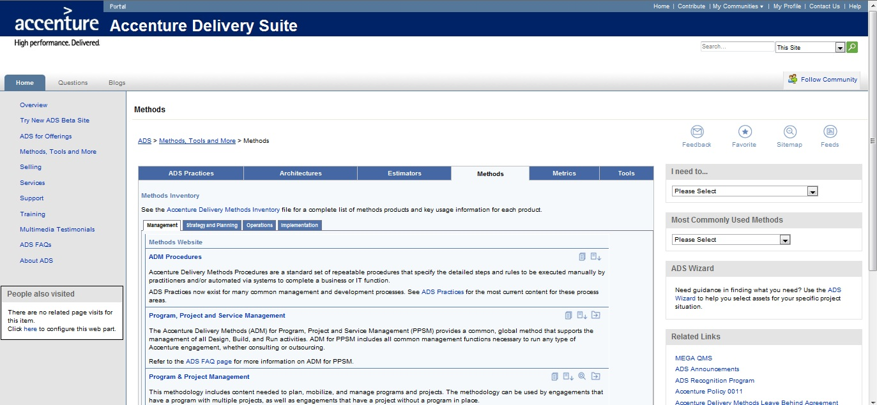

Working with Application Simulations

On the next page, and throughout the remainder of this course, you will be using Show Me demonstrations and Try Me simulations to learn about the structure and proper usage of ADM. This page will provide some helpful tips for navigating through these interactions.

You will launch an application simulation by clicking the "Show Me" or "Try Me" button.

Once you launch a simulation, it will begin playing automatically; however, you will have the ability to progress through each point in the simulation by clicking on the Next buttons as they appear. Also, you can control the simulation (pause, fast forward, rewind, etc.) from the controls at the bottom of the simulation. There will be on-screen captions to describe what you're viewing and guide you along the way. If you make an incorrect response, you will receive a further clarifying hint on the screen.

Click the simulation controls below to see a description of their function.



Please Note: At the time this course was developed, the Show Me and Try Me demonstrations were created using ADM version 5.1. ADM has since gone through maintenance updates. Some of the graphics and navigation may be slightly different from the current version of ADM. For example:

* The ADM graphic on the home page has changed slightly. In ADM version 5.1, the Change Enablement and Service Introduction workstreams were red in color; in the current version, they are now white in color.
* The work products and checklists may take fewer clicks to access.
* The Quality-related Content View page has been updated to align with the latest ADM for PPM changes.

A Quick Tour

This walkthrough demonstrates how to navigate ADM for Custom Development at a high level. This demonstration will be top-down, to show the process of going from general concepts to the specific actions needed to complete a task or tasks.

Click on the Show Me button below to watch a guided demonstration. These demonstrations are designed to allow you to learn at your own pace, so please note that there is a navigation control at the bottom of the window that allows you to pause, rewind a step or restart the demonstration.

https://mylearning-products.accenture.com/SEF_ADMv3/ADF_ADM/cImages/showme_button_n.gif

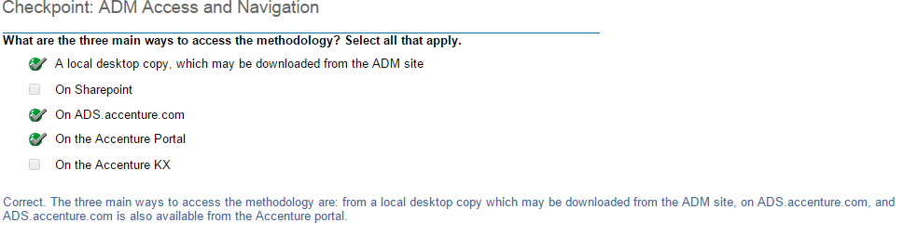

Topic Summary

In this topic you learned:

* The framework of ADM, the main content types and how they are related to each other.
* How ADM uses the vertical bars to represent the various stages of work within a project and the horizontal bars to represent the different domain or area of work called workstreams.
* The methodology presents three key types of content : Processes, Work Products and Roles.
* For every activity mentioned in ADM there is a discipline page, which provides a schematic to show the tasks within the activity and their dependencies.
* Transition points are a special kind of task dedicated to transitioning already validated deliverables to the next team responsible for continuing the project.
* For each deliverable (and composite deliverable) you can access detailed information and templates/samples on work product-artifact or work product-deliverable pages.
* Roles are the skill sets needed to complete a task. There are two types of roles in the methodology: Primary and Additional performers.
* The methodology provides additional assistance for users in the form of guidance: guidelines, checklists, external resources (including practices), and samples/templates.
* In ADM, every activity, task, and document has a predefined ID.

Moving forward, you will spend some time considering the question “When should I use ADM?” and learning how to use ADM with other methodologies.

Topic Introduction

The purpose of this topic is to provide learners with some best practices around how to make the most of the Accenture Delivery Methods. This topic also explains differences between how managers, developers, and designers use ADM.

Scenario Background

This section introduces a scenario-based story, starting with the Plan stage.

* During the remainder of this course, you’ll be playing the various roles of Project Manager, Developer, and Designer.
* When determining project scope, the Project Manager starts with the Plan stage, as it is the first activity to initiate the project.
* As we progress through these ADM demonstrations, emphasis is placed on the double perspective of the situation – Project Manager as a planner and as a practitioner.
* This case study demonstrates and simulates the work that needs to be done to accomplish a custom software development project. (This project only involves a Level A Object-Oriented technology software package.)
* The goal of the project is to deliver a single release. The project will cover all ADM stages from Plan to Deploy. (For the purpose of this course, we will emphasize the Analyze-Design-Build-Test stages in particular.)
* The overall project approach is to have several teams split the work over the various stages.
* The Project Manager is experienced and wants to encourage the team to use ADM to the fullest extent possible.
* The team members, from Assistant Manager to Designers and Developers, all have work experience, but this is the first time that they are working with ADM.

At a very early stage in the project, the Project Manager identifies the resources needed for the project. He realizes the team’s lack of experience in using ADM, so he calls for a meeting with the Account Manager and the Team Lead. The purpose of the meeting is to give an overview on the key features of ADM and to provide them with the way to leverage ADM for themselves and their team members. This demonstration helps communicate how it starts by communicating the results of the Plan stage.

Click on the Show Me to watch a guided demonstration.

https://mylearning-products.accenture.com/SEF_ADMv3/ADF_ADM/cImages/showme_button_n.gif

Click on the Try Me below to work through a hands-on simulation.

https://mylearning-products.accenture.com/SEF_ADMv3/ADF_ADM/cImages/Tryme_button_n.gif

Making the Most of ADM

ADM can make your job easier, regardless of whether you are involved in planning or implementing work. Understanding the best way to leverage the Methods in each situation enables you to improve the quality, efficiency, and repeatability of your work.

Given different situations, it’s critical to understand how to leverage ADM in the various roles that you may play (e.g., Manager vs. Designer vs. Developer) and:

* Know how to quickly get useful information for your activity or task.
* Understand what information is addressed and to whom.
* Understand how to move from your project’s Plan activities to execution.
* Be able to locate important information at the task and step levels, as those levels of detail will help you to complete your work more efficiently.
* Identify which skills are required for which roles.
* Access and familiarize yourself with key considerations.
* Leverage job aids and templates to accelerate the learning curve (as a new practitioner).
* Confirm completion and repeatability of the approach to fulfill task and quality objectives.
* From an activities' perspective, be able to quickly identify the key issues to be considered for planning, managing, staffing, and successfully completing the activity.

Know How to Read Information - Planner vs. Practitioner

A project involves strong and complex interactions among multiple teams, releases, processes, and technology. To address this complexity, ADM is designed to support personnel with differing information needs.

ADM is geared to two key types of users: planners and practitioners. These broad classifications provide a basic guideline for determining which information is most applicable to different types of personnel, based on the type of work for which they are responsible.

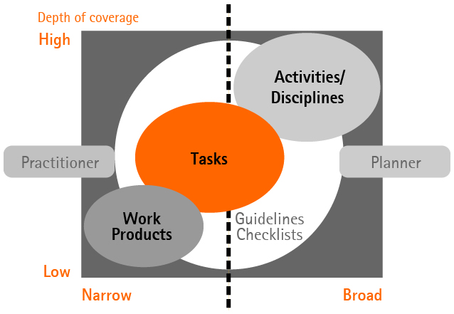

Planners and Practitioners: Role Differences

* The distinction between a practitioner and a planner exists in terms of roles or frames of reference rather than actual personnel.
* In reality, an individual may plan work and do work as appropriate, and hence can be considered both a planner and a practitioner.
* ADM uses the concept of a practitioner to identify the methodology information required to execute the Method's processes and to complete the required work products to the desired level of quality.

Planner Use of Methodology

Individuals responsible for structuring, estimating, and managing work on a unit, program or project, or leading a sales effort represent the planner role. A planner's activities occur whenever there is a need to evaluate a potential course of action, create a work plan, or manage a team. Information at the activity level is organized specifically to meet the needs of planners.

This table looks from a planner's perspective at what information is available for each activity and how to best use ADM activities, or Disciplines.

|  |  |  |
| --- | --- | --- |
| **Activity or Discipline Level** | **Purpose for Planner** | **How it helps the Planner** |
| Work Product Flow View | Illustrate the relationships among the tasks of an activity. | The Work Product Flow View can help planners gain an understanding of the overall structure and scope of work within an activity. |
| Purpose | Describe the purpose and intended outcomes of the activity. | This section is used by planners for initial guidance regarding the relevance of the task to the work. This also includes a planning chart that can help planners gain an understanding of the overall structure and scope of work within an activity. |
| Deliverables/Work products | Are produced as a result of the work conducted in the activity. | Planners should review the deliverables listed in this section as they are planning the work to ensure that they understand the desired result of an activity. |
| Roles | Define the responsibilities of a team member. | This information is useful in staffing and balancing the workload of a project. |
| Relationships to Other Workstreams | Explains the dependencies of this activity or workstream on other activities, and in turn what other activities need from the activity. | This information is useful in solutions planning, technical architecture, deploy and Service introduction. |
| Staffing | This includes important considerations for staffing the project. | This information helps in planning resources per task. Planners can staff the requirements team with active, empowered members from the business community. |
| Key Considerations | These explain the dependencies between this activity and other activities or workstreams. These also include the key issues to consider for planning, managing, and successfully completing the activity. | Considerations are used to document key issues, practical advice, and intangible factors related to the activity. This section can be helpful when considering how to structure the work, or how to manage work in progress. |
| More information | Lists any checklists, guidelines and other resources that are related to the activity. | Such guidance materials orient the planner to the nature of the work conducted, when it can be considered complete, and how it is structured. |
| Team allocation | This section lists the roles associated with the activity and details each role’s level of participation with the work products and tasks. | With this section, the planner can quickly view what staff will be involved during this activity, so the planner can ensure resource availability and mobilization. |

Practitioner Use of Methodology

Practitioner is a collective term for the personnel responsible for performing the business capability by executing the processes within the methodology. There are many different types of practitioners, ranging from account team members, application designers, to unit leads to service management experts.

This table looks from a practitioner’s perspective at what information is important and how to best use ADM tasks.

|  |  |  |
| --- | --- | --- |
| **Task Level** | **Purpose for Practitioner** | **How it helps Practitioner** |
| Purpose | Within a task can help define the objectives and intended outcomes of the task. | Planning charts illustrate how work should be conducted, and also point out iteration conditions. The planning chart provides practitioners with a view of the entire scope of work that must be performed at the task level. |
| Input and Output | Information that is generated and captured during the execution of a methodology process. | Work product templates and examples can be used to structure the details of the work contained within a task. Understanding the structure of this information is critical to completing the work successfully. |
| Roles | Define the responsibilities of a team member. | This information is useful in understanding what expertise the practitioner needs to execute, assist, or review the work. |
| Steps | Provide an explanation of each step in a task's planning chart. | They provide the practitioner with additional detail for completing each step of the task. |
| More information section | This lists checklists, guidelines, and other resources that are relevant to the task. | Technique and guideline materials are particularly useful for practitioners, as they include specific detailed explanations of how to conduct the work. |
| Key considerations | Describes the key issues to consider for planning, managing, and successfully completing the task. | Understanding the planning considerations and the advice they contain is just as important for personnel executing the work as it is for those personnel planning the work. |

Checkpoint: Activities and Purposes

Click on the appropriate cell to assign the different activities and their purposes for planners and practitioners to the appropriate column. Click “Submit” when complete.

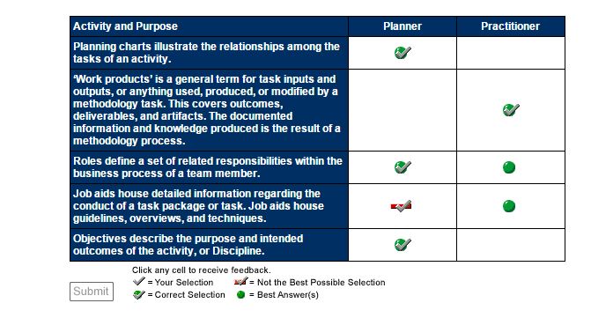

Topic Summary

The principal purpose of this topic was to explain the differences between how practitioners and planners use the activities, or Disciplines, and tasks within ADM. Efficient use of ADM will always have a positive impact on projects, so familiarity with the topic helps users of ADM.

In the next topic, we will provide a walkthrough of the process steps and work products associated with the Plan stage. You will also continue the scenario, which provides more hands-on opportunities to use ADM.

Topic Introduction

The purpose of this topic is to provide an overview and hands-on walkthrough of the process steps and work products associated with the Plan stage.

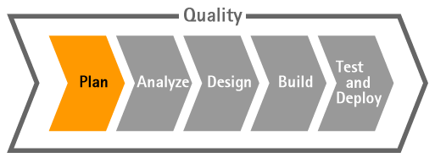

Testimonial: Benefits of ADM in the Plan Stage

This testimonial presents some of the benefits derived from using ADM during the Plan stage of a client project, and provides an example of the positive impact that ADM made on a client.

Scenario Update: Plan Stage

Your Project Manager has already described to you and your team about the different ways to use ADM based on your responsibility. Now your Project Manager wants to show you how to leverage ADM as a Planner or as a Practitioner (or Doer) in the Plan stage.

Overview of Plan Stage from a Planner Perspective

This demonstration focuses on the major items the Project Manager needs to know about the Plan stage. The Project Manager will read through the following sections:

* The work planning schematic helps to understand in one look all tasks to be performed within the discipline/activity.
* The Main Description section helps in understanding the overall goals of the Plan stage. It also discusses and lists key inputs and key outputs.
* The Work Product Flow View links you to a view of all key ADM for Custom Development work products. You can use this view to see how the Plan stage work products fit into the overall flow of work products.
* Key Considerations gives key integration / relationship points to other workstreams, and provides key considerations for planning, staffing, and managing the Plan stage.
* More Information can be obtained from Checklists, Guidelines, and Supporting Materials.

Click on the Show Me below to watch a guided demonstration.

https://mylearning-products.accenture.com/SEF_ADMv3/ADF_ADM/cImages/showme_button_n.gif

Reminder: At the time this course was developed, the Show Me and Try Me demonstrations were created using ADM version 5.1. ADM has since gone through maintenance updates. Some of the graphics and navigation may be slightly different from the current version of ADM.

Overview of Plan Stage from a Practitioner Perspective

In this demonstration we will read through the 1100 Plan Discipline from a Practitioner, or Doer’s perspective. Reading from this perspective helps identify how to get the work done.

The key purpose of the Plan stage is to:

* Review project scope and understand high-level requirements.
* Review and confirm the current capabilities of the organization in terms of business processes, applications, technology, and change enablement.
* Review and update the solution blueprint, a high-level design, or blueprint, for each area of the solution.
* Review and refine various implementation options. Search for and select Accenture assets and external products that best meet the functional requirements.
* Review and refine the strategies for developing, testing, piloting, and deploying the solution.

Click on the Show Me below to watch a guided demonstration.

https://mylearning-products.accenture.com/SEF_ADMv3/ADF_ADM/cImages/showme_button_n.gif

Schematic

The work planning schematic describes an activity as a set of tasks. Each task lists the deliverables or work products that should be ready when the particular task gets completed.

Click on the Show Me below to watch a guided demonstration.

https://mylearning-products.accenture.com/SEF_ADMv3/ADF_ADM/cImages/showme_button_n.gif

Key Outputs Section

The Work Product Flow View lists all key deliverables or work products involved across the lifecycle of ADM for Custom Development. This view takes a high-level look at this Method’s key work products and their lifecycles, and the relationships among the work products.

To get a view of an activity’s specific work products, you can view the Key Inputs and Key Outputs for the activity.

You can also see how these specific inputs and outputs fit within the larger cross-stage view.

Click on the Show Me below to watch a guided demonstration.

https://mylearning-products.accenture.com/SEF_ADMv3/ADF_ADM/cImages/showme_button_n.gif

Specific Information about Specific Roles

While each work product will be assigned to the appropriate responsible role, it’s easy to get more details about different roles and necessary skills. They are clearly described within the Roles section.

Click on the Show Me below to watch a guided demonstration.

https://mylearning-products.accenture.com/SEF_ADMv3/ADF_ADM/cImages/showme_button_n.gif

Application Designer Role: Required Skills

As illustrated in the previous demonstration, you can read about a role’s particular skills and responsibilities using the Methods.

Let’s look more closely at the Application Designer role. The Application Designer role can be defined by the list of skills required to be able to complete assigned tasks.

The key responsibilities of Application Designers are to:

* Assist in defining and reviewing requirements and use cases for the application.
* Use the business process requirements to drive out application requirements and metrics.
* Design the application to meet the business process design and application requirements.
* Validate the design with the stakeholders to ensure that the design satisfies the requirements.
* Supervise other designers or developers in completing designs.
* Inform the technical architect and project manager of any issues that may affect other areas of the project.
* Participate in quality management reviews, as outlined in Verification and Validation Overview, ensuring the application design and related work products satisfy the requirements.
* Participate in transitioning the designs to the developers, and ensure a clear and complete understanding of the designs.
* Ensure that other team members, such as the human performance architect, the integration solution designer, and the service introduction lead, have the information they need to successfully complete their work.
* Complete all appropriate documentation required by the developers, testers, deployment team, and application management team that will maintain the application.
* Design the application user interfaces, classes, and components.

On the Application Designer role page in the Methods, the upper graphic illustrates the key tasks (Performs) and work products (Responsible for). For a listing of additional tasks and work products, see the Additional Relationships section.

Click on the Show Me below to watch a guided demonstration.

https://mylearning-products.accenture.com/SEF_ADMv3/ADF_ADM/cImages/showme_button_n.gif

1121 Refine High-level Requirements: Process Steps

It is important to have a deep understanding of the “how to” for each task by understanding the specific steps for the task. Having a comprehensive, step-by-step approach for a task makes sure that all outcomes will be complete and consistent over all projects.

In this demonstration we’ll take a look at how an ADM user can review the tasks he or she is responsible for in his or her role. In this instance, we’ll look at the 1121 Refine High-level Requirements task, which is performed by the Business Architect.

Click on the Show Me below to watch a guided demonstration.

https://mylearning-products.accenture.com/SEF_ADMv3/ADF_ADM/cImages/showme_button_n.gif

Scenario Update: Transition to Other Project Management Team

By completing tasks as defined within an activity process flow, the Project Manager provides an update  to the team that they were able to achieve all tasks quickly and in a comprehensive way.

Therefore, leveraging ADM enables the use of a comprehensive approach for the Plan stage, supporting quality and leveraging Accenture experience. For instance, a New Joiner Manager at Accenture must be able to follow ADM to complete a project, following the same standard processes that our experienced Project Managers follow.

* Solution Planning happens during the Opportunity phase, with the intent to produce planning deliverables at the level sufficient for estimating and selling the work. It is typically done in a short timeframe during the proposal development period. If the solution planning deliverables are produced at the level sufficient for the team to proceed to the Analyze stage, then most Plan stage tasks can be condensed. Otherwise, the planning work started as part of the Solution Planning effort should be continued in the Delivery (Plan) phase.
* Depending on your project, you may transition to Plan execution, and this may be the role of the next Project Manager. Or, it may be your role, as your project moves to the next stage. Regardless of which project manager assumes responsibility, the Plan and Mobilize task guides the Project Manager in this next step.
* As the Project Manager did for the Plan Stage, so too the Project Manager for the next stage, Analyze, will leverage the activities / disciplines and tasks in ADM to perform their work.

The Project Manager, along with other leads, is responsible for developing, implementing, and maintaining the Project Plan, including the configuration management, risk management, project measurement, and quality management plans.

Topic Summary

You've just completed a walkthrough of the ADM Plan stage. To this point, we have examined:

* How ADM is organized overall and how you use it differently according to your Planner or Practitioner (Doer) role.
* How activity / discipline pages are organized in ADM.
* How to interpret and leverage ADM activity sections, such as:
  + Work planning schematic
  + Descriptions
  + Relationships with other workstreams
  + Key Planning, Staffing, and Managing considerations
* How to get more information about role definitions, skills required, job aids, and accessing work products, templates and/or samples

The next topic will continue the practical overview by working through the Analyze stage.